**Task 1: Write Regex symbols and their purpose**

1. ^ - Matches starting of a string
2. $ - Matches end of a string
3. [] – Matches any one character inside the brackets
4. [^] – Does not match any character that is inside the brackets
5. \ - This is for escaping special character
6. . – Matches single character
7. * - Matches 0 or more characters
8. + - Matches 1 or more characters
9. {n} – Matches exactly n times for a given character or a string
10. {n,} – Matches n or more times
11. {n,m} – Matches between n and m
12. () – This will group the content that matches the pattern given inside the braces
13. \d – this will match the digits
14. \w – this will match the words
15. \s – this is to match the spaces

**Task 2: Features of Linux OS**

1. Linux is secure
2. It provides Command Line Interface
3. Stable and reliable
4. Runs scripts using CLI
5. It supports different types of files

**Task 3: What is Kernel**

Kernel plays a key role in Linux OS.

1. It manages CPU and tells it which program to run and helps in switching between different program just like multi tasking
2. Manages processes
3. Manages memory

**Task 4: BASH full form and explanation**

BASH: Bourne Again Shell

It is a CLI used in Linux, it allows to interact with system using commands. Means it takes commands like ls, cd, pwd, touch, cat and executes them accordingly.

**Task 5: Diff between Linux and Windows**

1. Linux is open source, which means any one can see and make the changes, whereas windows is owned and controlled by mircosoft
2. Linux support CLI, users work with it using commands and in windows users are focused on graphical interface, which helps users work easily
3. Linux is more secure compared to windows

**Task 6: Basic components of Linux**

1. Shell – this is to work with system using commands
2. Kernel – this is to manage the system processes and allocates RAM
3. System functions – these are small functions helps linux to do simple tasks such as copy, move, create

**Task 7: Is it legal to edit Kernal? when do you think we have to in case?**

Yes, it is legal. As Linux is open source, anyone can make changes and it is good to make changes when we are optimizing the performance or fixing the bugs otherwise in the case of adding features.

**Task 8: What is LILO**

LILO means Linux Loader. Which loads the boot menu and performs actions accordingly and passes the control to Kernel.

This is similar to POST test but a bit different as POST focuses on Hardware components checking and LILO focus on RAM and memory management.

**Task 9: What is shell? How many shells are there and what are they? can you explain.**

Shell is a command line interface. There are multiple shells. Below are a few,

1. Bash
2. Korn shell
3. Power shell

**Task 10: What is swap space?**

Swap space is a component of hard disk and acts as a virtual memory. It comes into action when RAM is full or near to full, then the operating system will move the inactive data from RAM to swap space to free up space on RAM so that the system can function smoothly.

**Task 11: What is Mount? how do you mount and unmount file system in Linux?**

Mounting means making files accessible. We can do this using mount and umount commands.

**Task 12: What is chmod command? how to use it?**

Chmod is used for changing the file and directory permissions in linux. We can change permission such read, write and execute.

Basis syntax is: chmod u+rw sample.txt

Here u refers to user and rw refers to read & write permission.

We can also do this with numeric

4 – read; 2 – write; 1 – execute

chmod 755 sample.txt

7 (4+2+1) -> rwx given

5 (4+1) -> rx given

**Task 13: Can you add a new user account? Crate a new user in different ways and paste ss**

We can add a new user account using the below command

sudo adduser sai

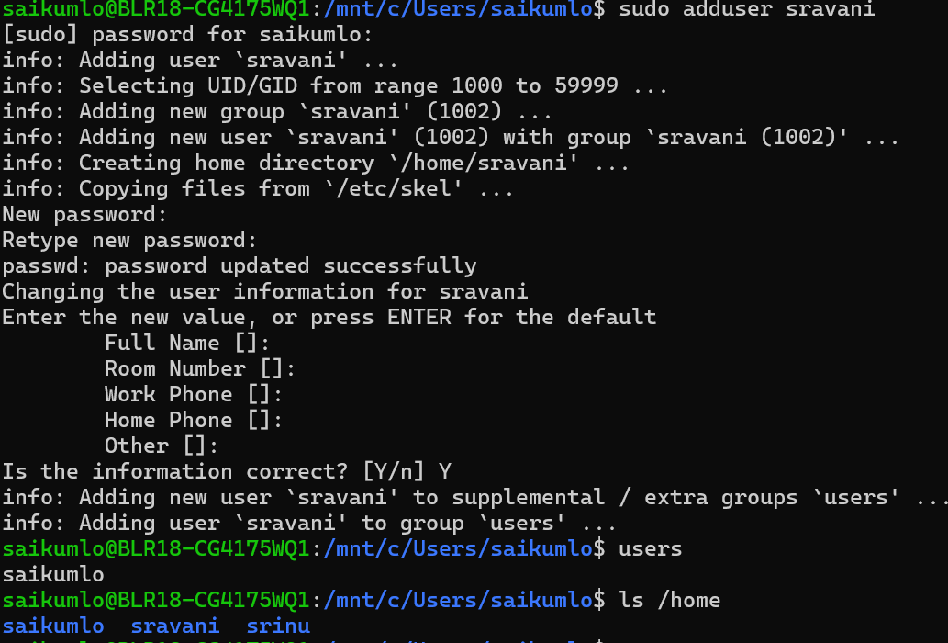

**Task 14: Can you change the password of a user?**

Yes, we can do this passwd command

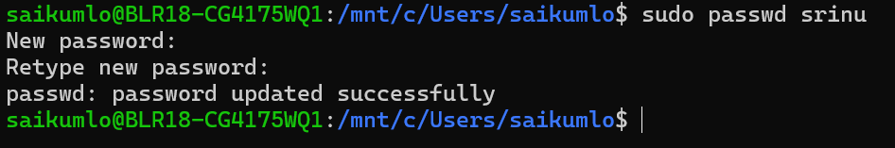

**Task 15: What is diff between Process and Thread?**

Process is an individual task that is running on system, each process in the system has a dedicated memory space. This separation helps processes to work efficiently without interfering other process memory.

Thread is like small units with in a process, there will be multiple threads with in a process. These threads will share memory that was allocated for a process and this shared memory across thread helps in communicating with other thread effectively.

**Task 16: Keep a file ready with some content in it for Grep command**

Done

**Task 17: Read AWK commands**

Done

**Task 18: How to check file access permission in Linux?**

We can use ls -l

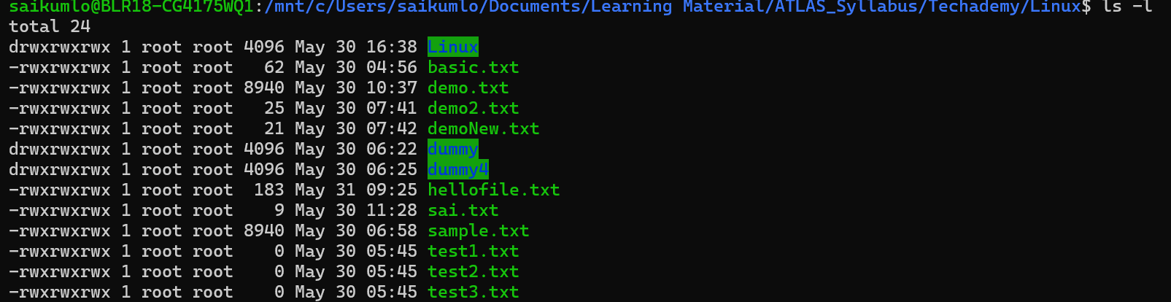

**Task 19: Default permissions for a new file?**

Default permissions: rwxrwxrwx

**Task 20: What is the command to change the permission to read only for the owner, group and all other users**

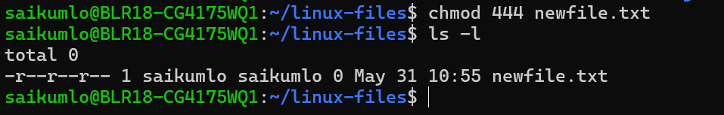

**Task 21: Can you change the file permissions to match the following:**

* owner: Read and Write
* group: Read
* other: no permissions (None)

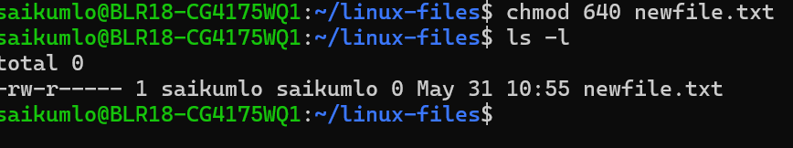

Task 22: What was the command for changing the file permissions to -rw-r-----?

chmod 640 newfile.txt

Task 23: **Change chmod.exercises permissions to -rwxr-x--x**

Change the file permissions to match the following:

owner: Read, Write and Execute

group: Read and Execute

other: Execute

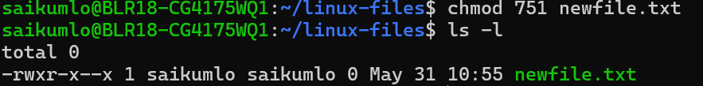

**Task 24: What was the command for changing the file permissions to -rwxr-x--x**

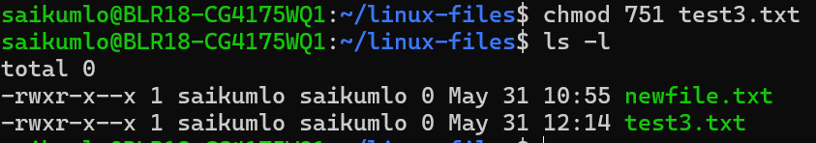

**Task 25: what will this command do?**

chown -c master file1.txt



**Task 26: what is a process?**

A process is a running instance of a program in memory, managed by the system.  
Each process has a unique id and its own resources like memory, CPU time.

**Task 27: What is command to check foreground process and background process**

We can check foreground / background processes using ps or ps-f command

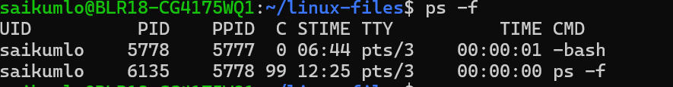

**Task 28: Can you list all the running processes?**

We can get all running process info using ps command

ps: it will give the running processes with in current terminal session

ps aux: this will give all the running processes list

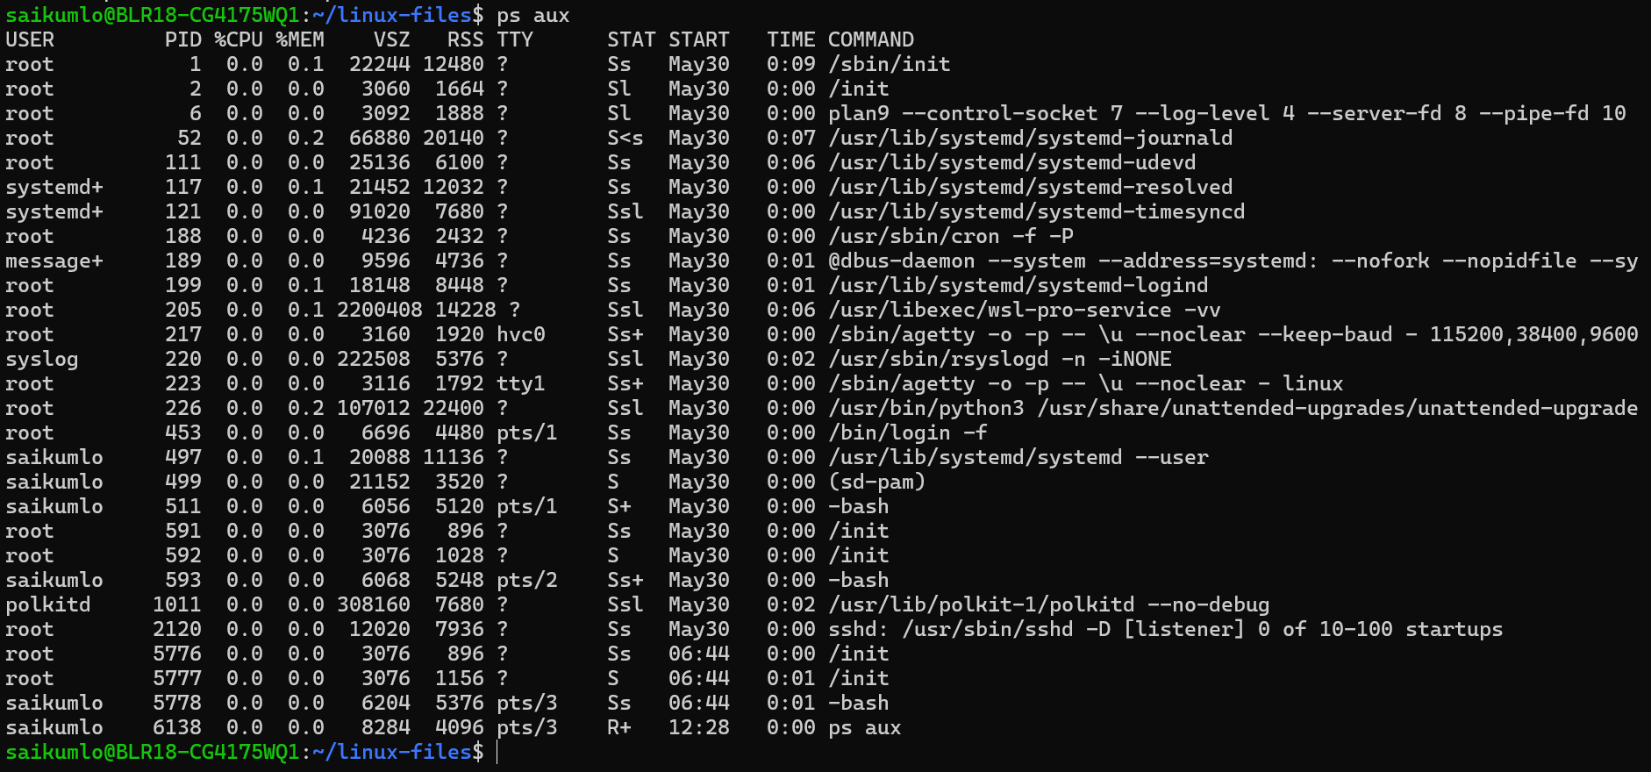

**Task 29: What will ps -f command do?**

ps -f shows more formatted info than ps command

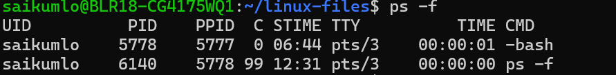

**Task 30: Can you create a variable name with your name in it**



**Task31: Can you above variable read only**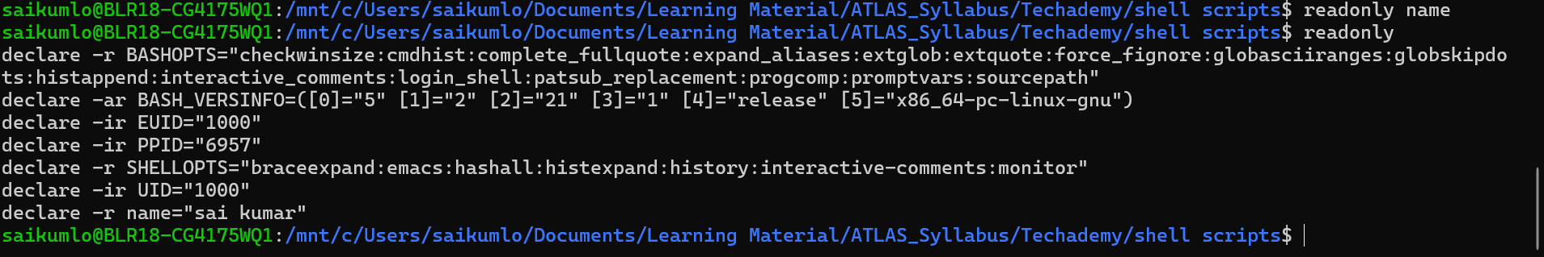

**Task32: unset the variable**

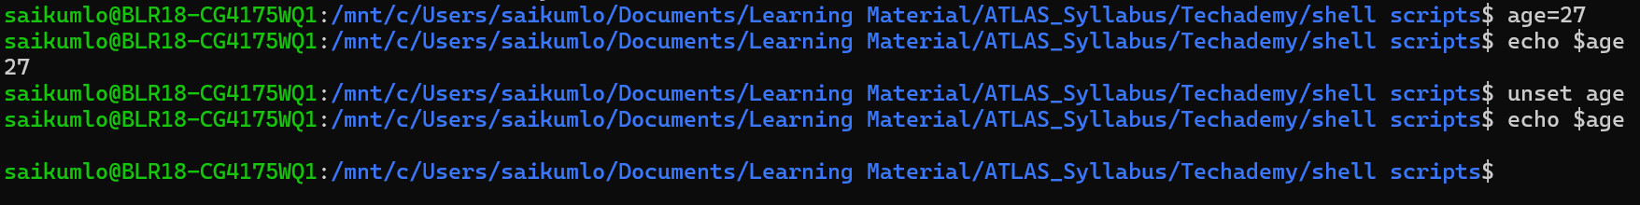

**Task33: Can u try to add a list of your friends names in an array and try to printout**

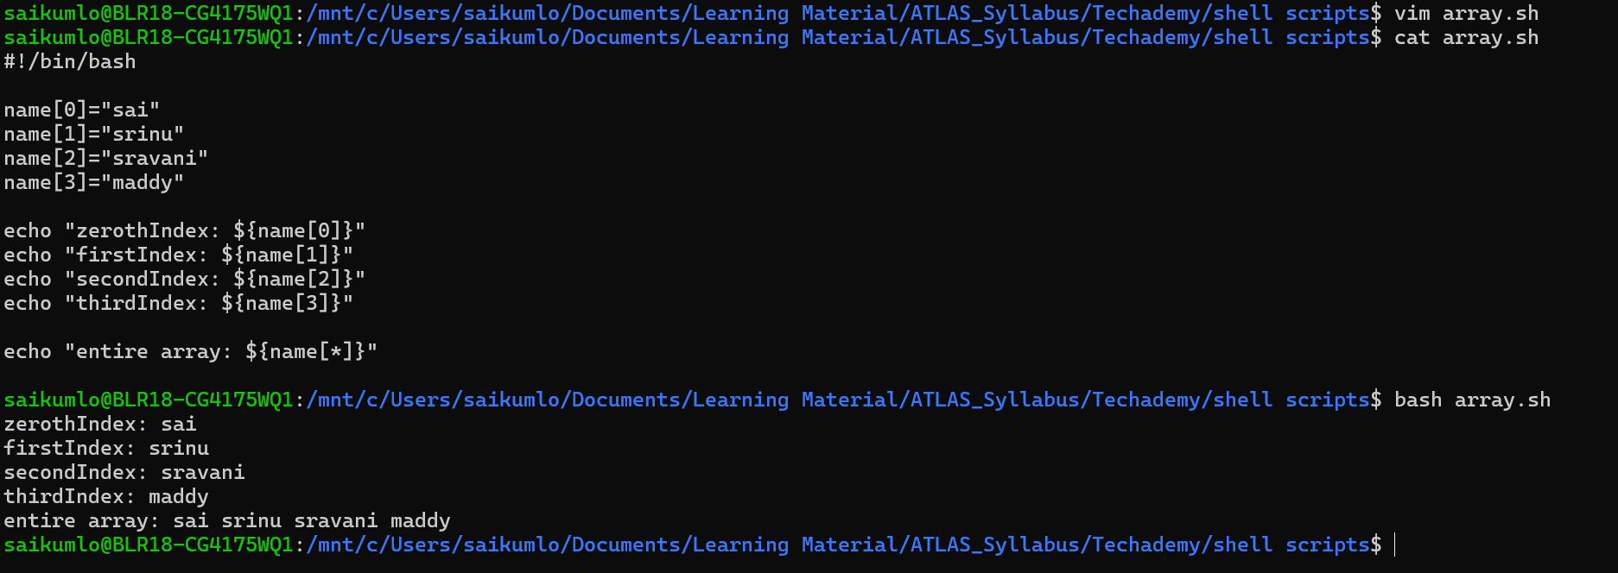

**Task34: Can you print all the list at once in an array**



**Task35: Output of below script**

a=0

while [ "$a" -lt 10 ] # loop1

do

b="$a"

while [ "$b" -ge 0 ] # loop2

do

echo -n "$b "

b=`expr $b - 1`

done

echo

a=`expr $a + 1`

done

